SCM Notes | Session 3: SC Drivers — Responsive vs. Efficient SC
Course: Supply Chain Digitization

Quick Recap (from Session 2)
- Competitive Strategy → Competitive Priority → Manufacturing Process → SC Strategy
- Cost focus: high volume, low variety → Assembly / Continuous process
- Differentiation focus: high variety, lower volume → Job Shop process
- SC strategy = Responsive (speed, fulfil customer need fast) OR Efficient (minimise cost)

1. SC Drivers — Overview
- Def: levers a SC uses to balance responsiveness vs. efficiency, and maximise overall SC profit
- 6 Drivers: Facilities, Inventory, Transportation (Logistical Drivers) + Information, Sourcing, Pricing (Cross-sectional Drivers)
Two categories:
- Logistical drivers: Facilities, Inventory, Transportation — physical entities
- Cross-sectional drivers: Information, Sourcing, Pricing — enable & coordinate the physical drivers
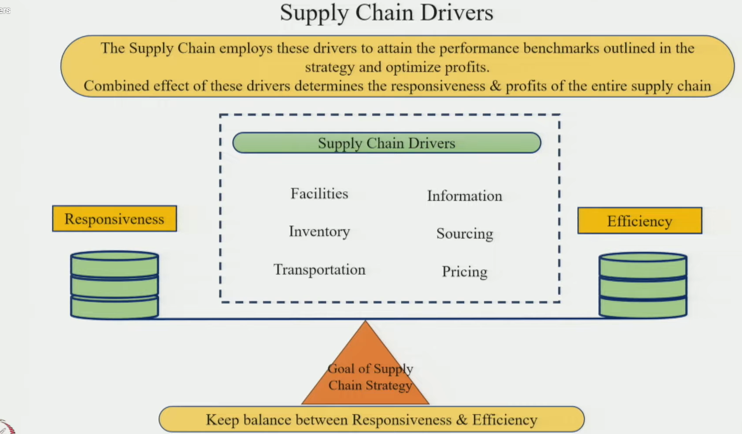

2. Driver 1 — Facilities
- Includes: plant, warehouse, retail store — places where inventory is stored/converted
- Role: receive, store, or convert RM / WIP / FG at each node of the SC
Three facility decisions:
- (a) Capacity:
- Large capacity → handles higher volumes, fewer resources, lower unit cost → Efficient SC
- Small capacity → adaptable to demand/market changes, higher unit cost → Responsive SC
- (b) Location:
- Centralised → economies of scale → Efficient SC
- Decentralised (closer to customers) → Responsive SC
- (c) Production facility type:
- Flexible (multi-product, shared equipment/workers) → higher variety → Responsive SC
- Dedicated (fixed machines + manpower, limited variety) → large qty, low variety → Efficient SC
- (d) Warehouse type:
- Cross-docking → inventory moves without long storage, mix-&-match per customer need → Responsive SC
- Dedicated storage → large volumes, minimal cost → Efficient SC
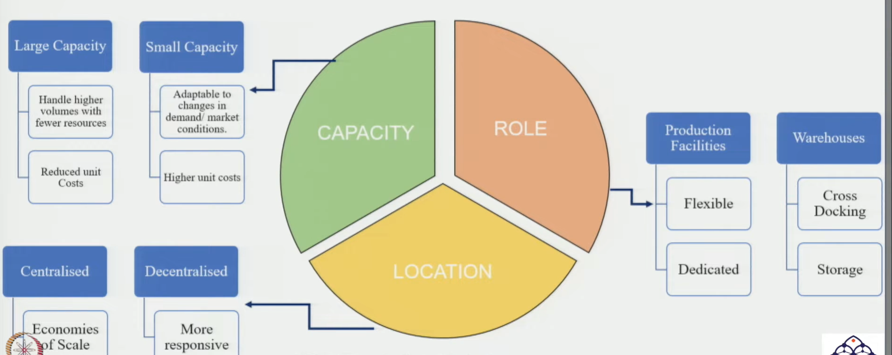

3. Driver 2 — Inventory
- Primary role: bridge the gap between supply & demand
3 Components of inventory decision:
- Cycle inventory: same qty ordered repeatedly in a cyclic pattern
- Safety inventory: minimum buffer stock to prevent stockouts / process disruption
- Seasonal inventory: extra stock carried during peak/seasonal demand periods
Inventory trade-off:
- High inventory: fulfils demand fully → Responsive SC BUT adds cost
- Low inventory: lowers holding cost BUT poor service level, lost customers → severe business penalty
Inventory location strategy:
- Responsive: carry high FG inventory → place it closer to consumers (faster availability)
- Efficient: carry FG at centralised location → order consolidation + transportation optimisation → lower cost
- Note: SC can be a mix of responsive + efficient (not always a pure strategy)
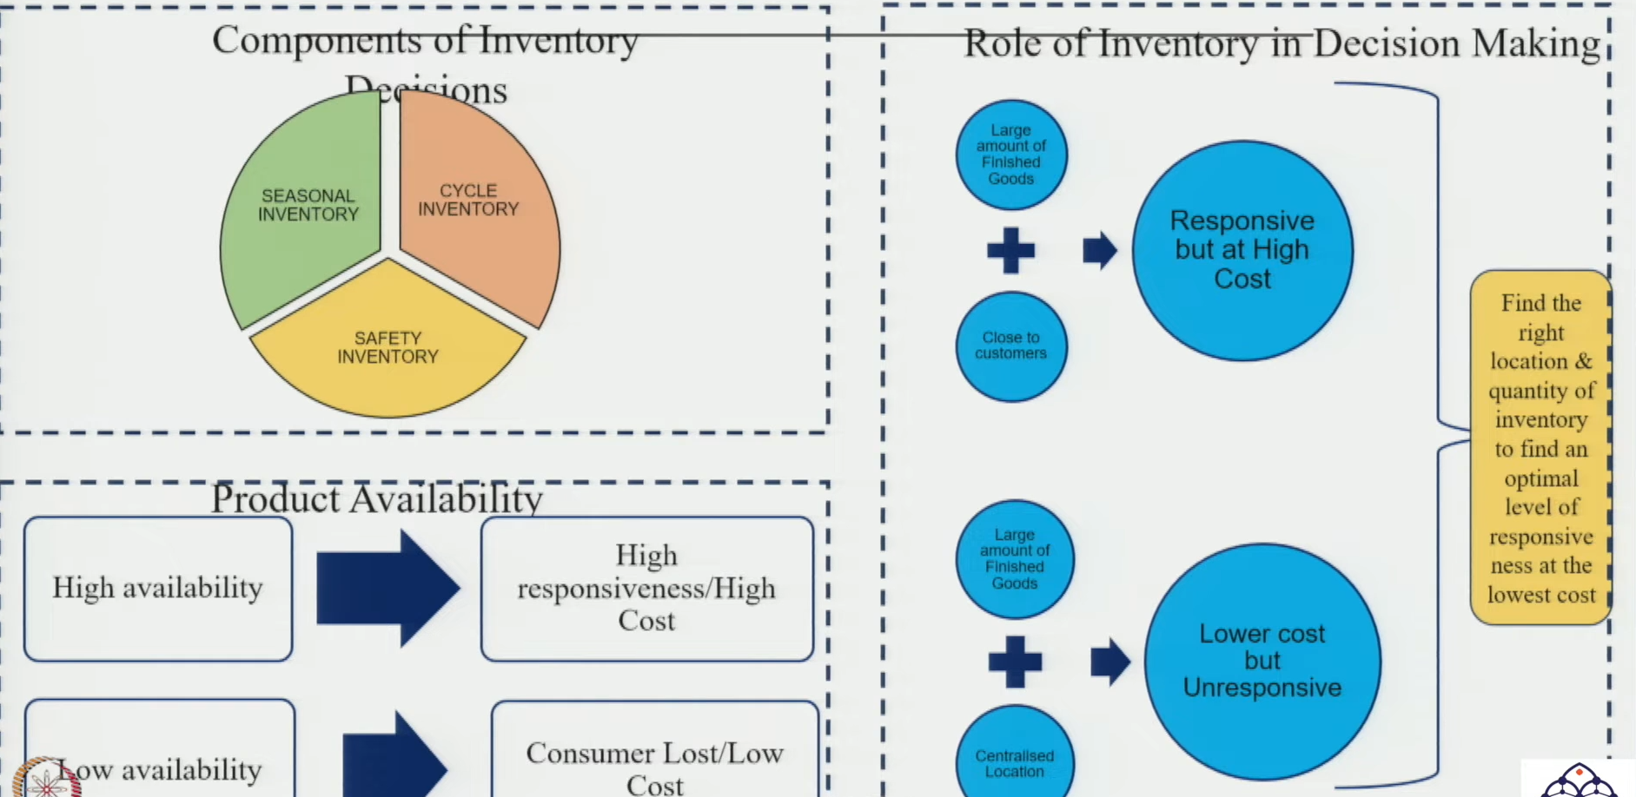

4. Driver 3 — Transportation
- Moves RM: supplier → manufacturer AND FG: manufacturer → final customer
2 Key transportation decisions:
- (a) Network design:
- Direct shipping: manufacturer → demand point directly (no intermediary)
- Through intermediaries: depending on whether SC needs to be responsive or efficient
- (b) Mode of transport:
- Air: fast, high cost → Responsive SC (suitable: high-value, low-demand products)
- Sea: slow, low cost, high volume → Efficient SC (suitable: low-value, high-demand products)
- Rail / Road: intermediate options (cost & speed balance)
Transport strategy summary:
- Responsive → Rapid transport: high-value / low-demand products; centralised facility stores wide variety; direct delivery to consumer
- Efficient → Low-cost transport: low-value / high-demand products; bring inventory closer to customers → minimise last-mile cost
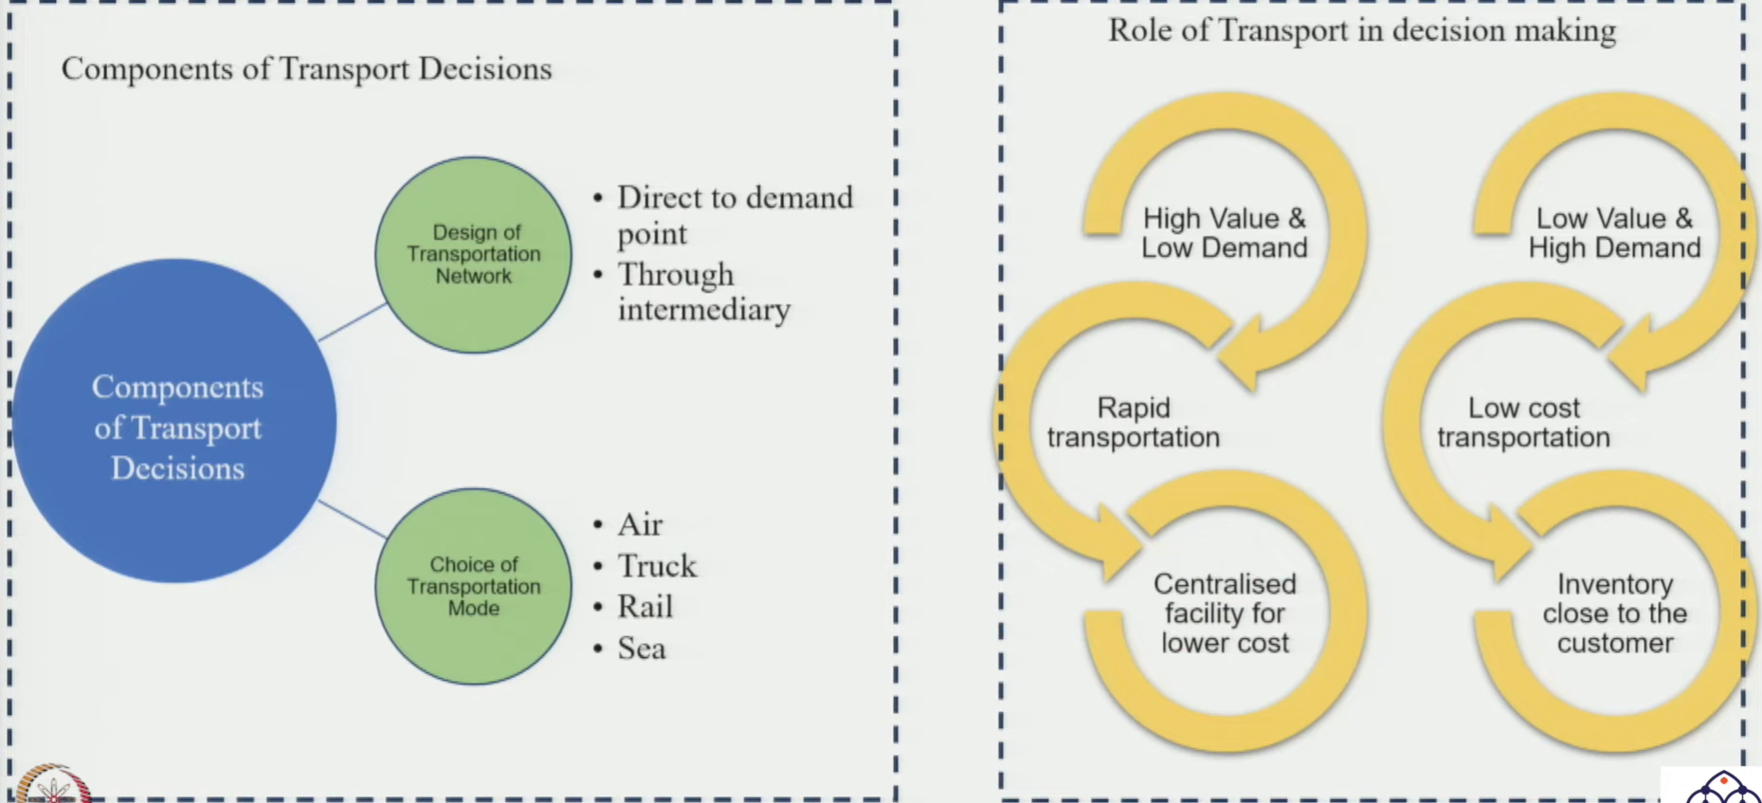

5. Driver 4 — Information
- Enables & coordinates all other 5 drivers; critical for both push & pull systems
Push vs. Pull (role of information):
- Push strategy: production based on forecast & historical demand → products made/services planned in advance of actual order → info system used for advance planning
- Pull strategy: production triggered by actual customer demand/order → info system enables quick response & partner collaboration
Other roles of information:
- SC coordination: every SC phase collaborates → maximise overall SC profitability through info sharing
- Cross-functional alignment: sales, marketing, production etc. all aligned to business requirements via information
Information for each SC type:
- Efficient SC: forecasting, inventory mgmt, supplier collaboration, production planning, transport optimisation
- Responsive SC: real-time visibility (ML methods), demand sensing, demand shaping via promotions, scenario planning → reduces response time

6. Driver 5 — Sourcing
3 components of sourcing decisions:
- Procurement: decisions on types of materials required (discussed in detail via Kraljic Matrix in future sessions)
- Sourcing strategy: single vs. multiple sourcing | in-house vs. outsourcing
- Supplier selection: identify requirements → find suppliers who can fulfil them
Sourcing for each SC type:
- Efficient SC: cost optimisation + economies of scale + supplier consolidation
- Responsive SC: supplier collaboration (handle disruptions quickly) + maintain base of alternative suppliers (no demand goes unfulfilled) + customisation strategies

7. Driver 6 — Pricing
Pricing strategies:
- Economies of scale pricing: suitable for big batch production — cost effective, saves changeover cost → Efficient SC
- EDLP (Everyday Low Pricing): price stays steady over time → predictable, Efficient SC
- High-Low Pricing: different prices at different times (discounts) → dynamic, Responsive SC
- Fixed Pricing: set prices → Efficient SC
- Menu Pricing: price varies by response time, location, or attributes → Responsive SC
- Key point: customers wanting responsiveness vs. efficiency are entirely different → right pricing strategy targets the right segment
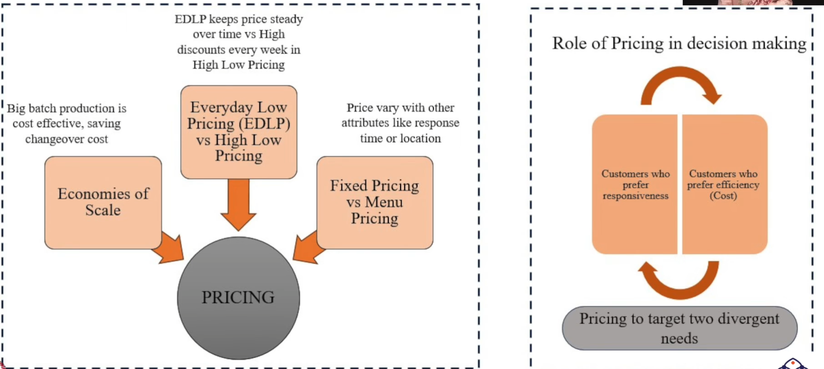

8. Master Summary Table (Exam-Ready)
Driver | Responsive SC | Efficient SC
Facilities | Decentralised, small capacity, flexible, cross-docking warehouse | Centralised, large capacity, dedicated, storage-based warehouse
Inventory | High FG inventory, placed closer to consumers | Centralised FG inventory, order consolidation
Transportation | Rapid modes (Air), direct shipping; high-value, low-demand products | Slow modes (Sea), economies of scale; low-value, high-demand products
Information | Real-time visibility, demand sensing, ML, scenario planning, pull system | Forecasting, inventory mgmt, production planning, push system
Sourcing | Supplier collaboration, alternate suppliers, customisation strategies | Cost optimisation, economies of scale, supplier consolidation, outsourcing
Pricing | High-low pricing, menu pricing (price varies by time/location) | Everyday Low pricing, fixed pricing, economies of scale pricing
✓ Exam Angle: "Explain the role of SC drivers in making a SC responsive or efficient." → Define responsive vs. efficient → name all 6 drivers with categories → use the table above to explain each driver’s role for both strategies.

